**Door Opening Product Testing System**

Daniel Peck

SIE 454A – 001

09 December, 2022

**Abstract**

The door opening product tester is a system that tests a manufactured product automatically that previously has been tested manually by quality engineers. The design is based on other testers in industry but must be made to accommodate testing of the new product since the product contains proprietary technology. The system allows for quality to be maintained while boosting production to meet increasing demand for the new product.

**Problem Statement**

A startup that manufactures door opening solutions (keypad, NFC reader, locks, etc…) has a new product that has been received very well. Management wants to increase production volume to meet the demand for the new product. They are aware that quality control can fall by the wayside when volume is increased. This is especially true for the new product because the design engineers behind it are manually conducting quality assurance testing. To increase volume, maintain quality, and free up time for the design engineers, the startup wants to create an automated testing system that tests all of the same requirements that the engineers have been manually testing.

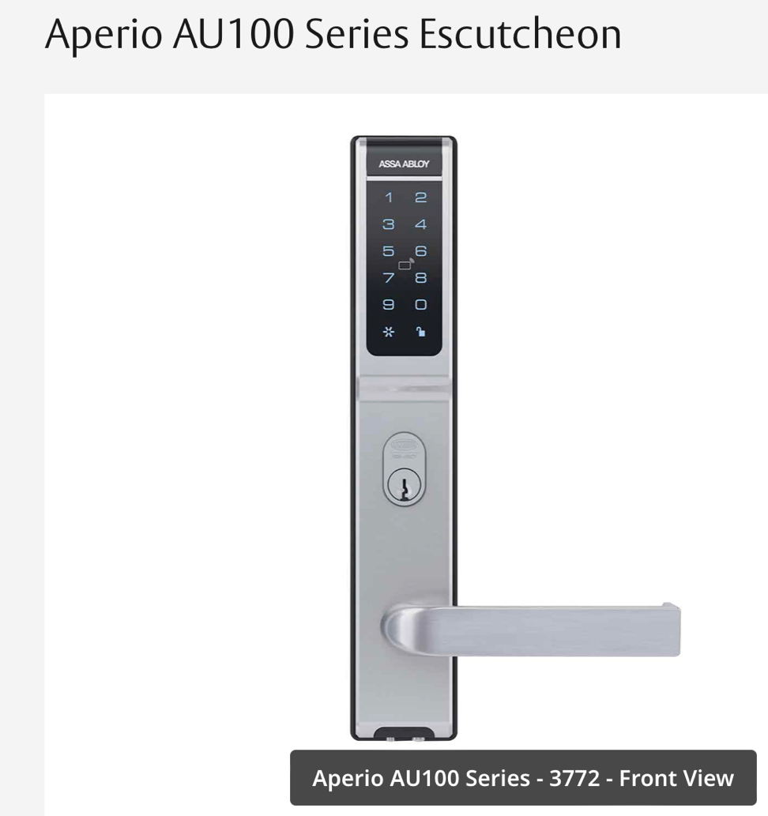The product to be tested looks similar to this:

But instead of a handle, the opening mechanism is automated.

**System Concept**

The testing system will interface with the product. The idea is that the only human involvement is attaching and detaching the product with the system. The system is essentially a box that an operator attaches the product to that runs various mechanical and software tests on the product and then displays pass/fails for each requirement it tests. If a product fails, the test results can be exported as diagnostics for an engineer to help them repair the unit. There is a mechanical testing subsystem and a software testing/diagnostics subsystem. The scope could also be increased to include a product automation subsystem so an operator could load in multiple products at a time to get tested and leave the tester to carry out its functions.

**System Boundary Diagram**

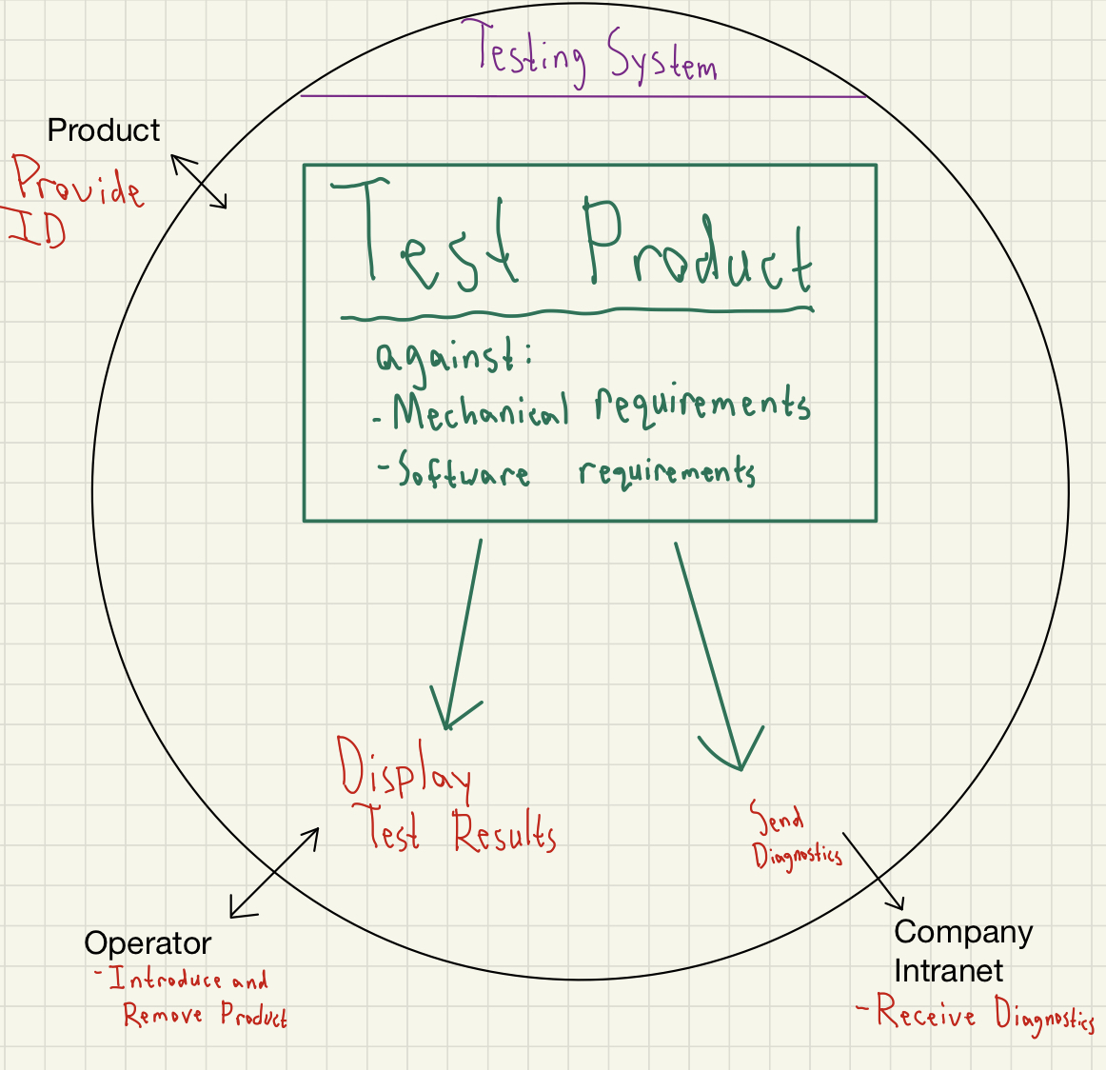

**Stakeholders**

The stakeholders of this system are:

-Assemblers/Testers

Assemblers are the main party that interfaces with the system, since they operate the system and verify results.

-Quality Engineers

Quality engineers receive diagnostics for malfunctioning units via the system.

-Customers

Customers want a quality product that is assured by a reliable system.

-Upper Management

Upper management wants to drive sales and customer satisfaction through quality assured products. They also want to work towards ISO certifications that require certain quality control practices and standards to be in place.

**Use Cases**

-A tester places a passing unit into the interface with the system. The unit interfaces with the system via wired and wireless connection. The system checks for correct placement in the interface. The system reads the data on the unit for unit identification.The system tests the unit against physical requirements. The system tests the unit against software requirements. The system displays passing results. The system saves the test data. The tester removes the unit from the interface.

-A tester places a failing unit into the interface with the system. The system checks for correct placement in the interface. The system reads the data on the unit for unit identification.The system tests the unit against physical requirements. The system tests the unit against software requirements. The system displays failing test results. The system sends test diagnostics to the company intranet. The tester removes the unit from the interface.

-A tester places a unit incorrectly into the system interface. The system checks for correct placement in the interface. The system displays a warning for the tester to check connections in the interface. The tester readjusts the unit and the test continues as normal.

-A quality engineer requests test data from the system. The system sends test data to the company intranet via wireless connection. The quality engineer accesses the data on the company intranet.

**Needs**

-The system needs to interface physically with finished goods.

-The system needs to read data from finished goods

-The system needs to verify a good interface with finished goods before testing.

-The system needs to test finished goods against mechanical quality requirements.

-The system needs to test finished goods against software requirements.

-The system needs to display test results in a way that testers can understand passes and failures on different tests.

-The system needs to store test data.

-The system needs to send failing test data to a company intranet.

-The system needs to be able to fulfill requests for test data via the intranet.

**Functions**

1. Verify interface
2. Display interface warning
3. Read data
4. Test mechanical requirements
5. Test software requirements
6. Display results
7. Send failing unit test data
8. Store test data
9. Send test data

**Functional Block Diagram**

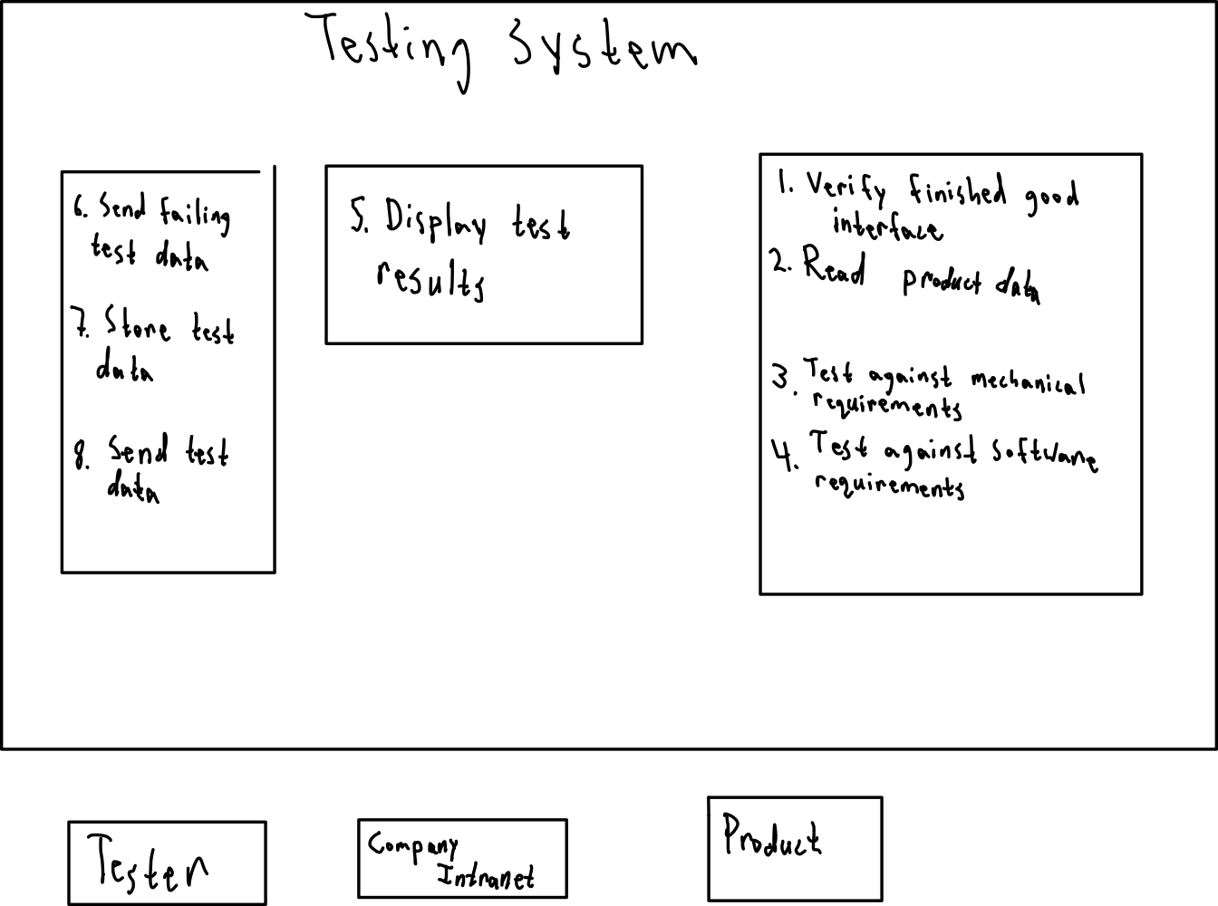

**Functional Flow Block Diagram**

C

B

A

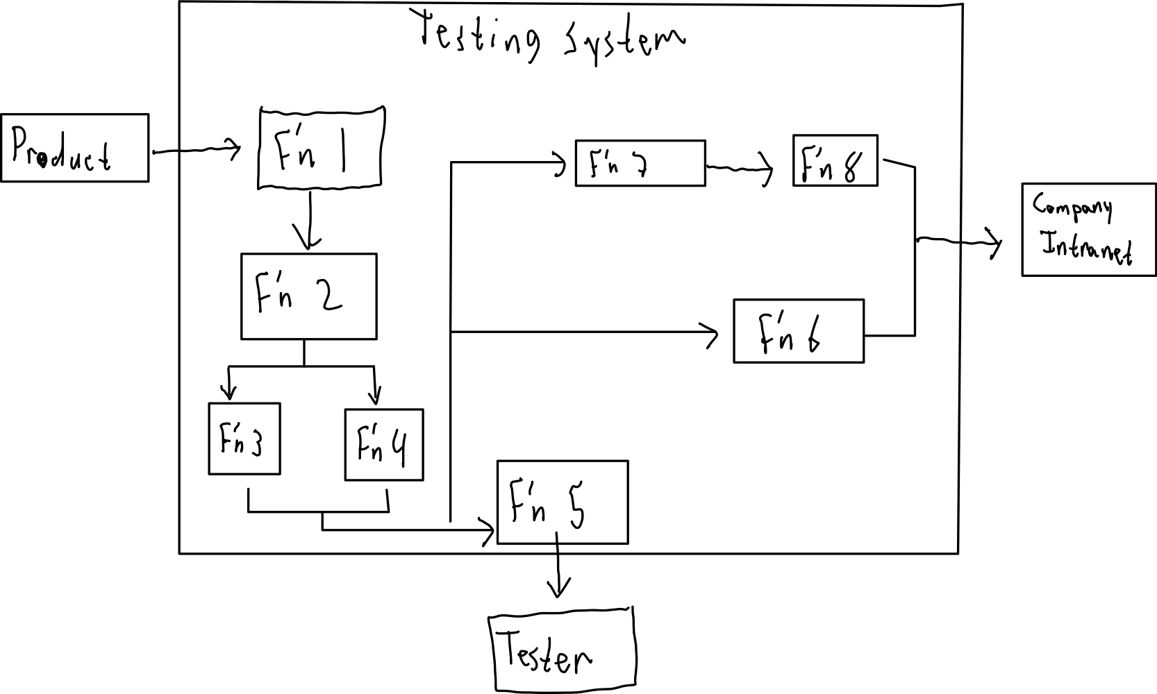**Interface Descriptions**

1. Product Interface:

This interface between the product and the verify interface function is where the tester places the finished unit for testing. There are wired connections for power supply and mechanical commands such as opening and locking. There is a wireless interface involved as well as the end user will be Verable to program their own product using an app. The wireless connection allows the tester to program the unit and test certain software requirements. There are sensors in the interface that measure how the unit moves to make sure it meets requirements.

1. Tester Interface:

This interface between the tester and the display test results function is a screen that displays correct product interface connection and test results after tests are completed. This interface also provides a graphical user interface that includes warnings about incorrect connection with the product and options for the tester to begin the test.

1. Company Intranet Interface:

This is an interface over a private network between company servers and the send test data and send failing test data functions.

**Requirements**

*Functional Requirements*:

1. The system shall verify that its interface with the product to be tested is correct.
2. The system shall display a warning when a unit is placed incorrectly in the interface.
3. The system shall read data from the product.
4. The system shall test the unit against mechanical requirements.
   1. The system shall finish mechanical testing within 60 seconds.
5. The system shall test the unit against software requirements.
   1. The system shall finish software testing within 30 seconds.
6. The system shall display test results.
7. The system shall send failing test data to a company intranet.
8. The system shall locally store test data
   1. The system shall store up to a month of test data.
   2. The system shall send test data as requested.

9.1 The system shall store up to one month of test data

*Characteristic Requirements*:

10.0 The system shall be an appropriate size to be included in a production line.

*Interface Requirements*:

11.0 The system shall interface with a product to be tested via wired connection.

11.1 The wired interface shall remain functional without replacement for one year of operation.

12.0 The system shall interface with a product to be tested via wireless connection.

13.0 The system shall interface with a product via sensors to collect test data.

14.0 The system shall interface with a tester via a display.

15.0 The system shall connect to a company intranet via wireless network connection.

*Environmental Requirements*:

16.0 The system shall operate in a factory environment.

**System Architecture**

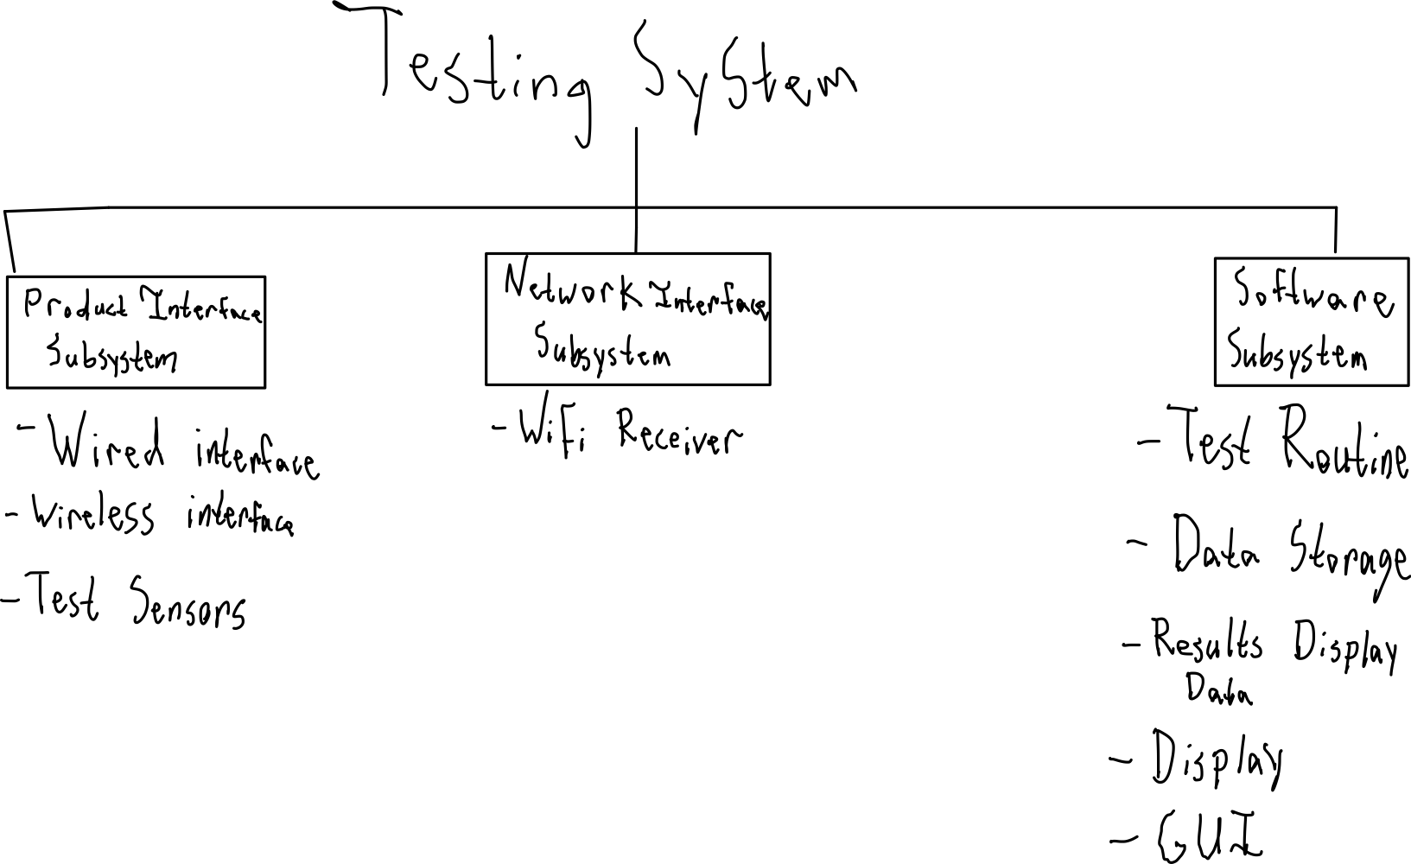

Requirements Flow-Down

|  |  |  |
| --- | --- | --- |
| *Product Interface Subsystem* | *Software Subsystem* | *Network Interface Subsystem* |
| *1.0*  *3.0*  *4.0, 4.1*  *10.0*  *11.0, 11.1*  *12.0*  *13.0* | *1.0*  *2.0*  *3.0*  *4.0, 4.1*  *5.0, 5.1*  *6.0*  *8.0, 8.1*  *9.0, 9.1*  *14.0* | *7.0*  *9.0*  *15.0* |

**Verification Matrix**

The verification matrix lists out all requirements and describes how said requirements will be verified. Verification is the practice of making sure the system functions according to the requirements. In other words, verification is the process of making sure the system was designed correctly. The four methods (indicated in the matrix by the columns T, A, D, I) of verification are test, analysis, demonstration, and inspection. Testing involves using scientific methods to verify functionality. Analysis involves modeling the system in some way and using data from the model to verify functionality. Demonstration involves seeing the system function to verify functionality. Inspection involves observing the system, be it visually or with measurements, to verify functionality.

|  |  |  |  |  |  |
| --- | --- | --- | --- | --- | --- |
| Verification Matrix | | | | | |
| No. | Requirement | T | A | D | I |
| A. | Functional and Performance Requirements |  |  |  |  |
| 1.0 | The system shall verify that its interface with the product to be tested is correct | X |  |  |  |
| 2.0 | The system shall display a warning when a unit is placed incorrectly in the interface |  |  | X |  |
| 3.0 | The system shall read data from the product | X |  |  |  |
| 4.0 | The system shall test the unit against mechanical requirements | X |  |  |  |
| 4.1 | The system shall finish mechanical testing within 60 seconds | X |  |  |  |
| 5.0 | The system shall test the unit against software requirements | X |  |  |  |
| 5.1 | The system shall finish software testing within 30 seconds | X |  |  |  |
| 6.0 | The system shall display test results |  |  | X |  |
| 8.0 | The system shall send failing test data to a company intranet |  |  | X |  |
| 9.0 | The system shall locally store test data |  |  | X |  |
| 9.1 | The system shall store up to a month of test data |  |  | X |  |
| B. | Characteristic Requirements |  |  |  |  |
| 10.0 | The system shall be an appropriate size to be included in a production line |  |  |  | X |
| C. | Interface Requirements |  |  |  |  |
| 11.0 | The system shall interface with a product to be tested via wired connection |  |  | X |  |
| 11.1 | The wired interface shall remain functional without replacement for one year of operation | X |  |  |  |
| 12.0 | The system shall interface with a product to be tested via wireless connection |  |  | X |  |
| 13.0 | The system shall interface with a product via sensors to collect test data |  |  | X |  |
| 14.0 | The system shall interface with a tester via a display |  |  | X |  |
| 15.0 | The system shall connect to a company intranet via wireless network connection |  |  | X |  |
| D. | Environmental Requirements |  |  |  |  |
| 16.0 | The system shall operate in a factory environment |  |  |  | X |

**Trade Studies**

Trade studies are analyses of different options that may be feasible as subsystems or components.

*Trade Study 1*

The network interface subsystem takes the form of a Wi-Fi card. Wi-Fi cards will interface with the rest of the system and allow for network and Bluetooth connectivity. There are a few criteria to evaluate potential options with: cost, security, and wireless speed. Here are the options:

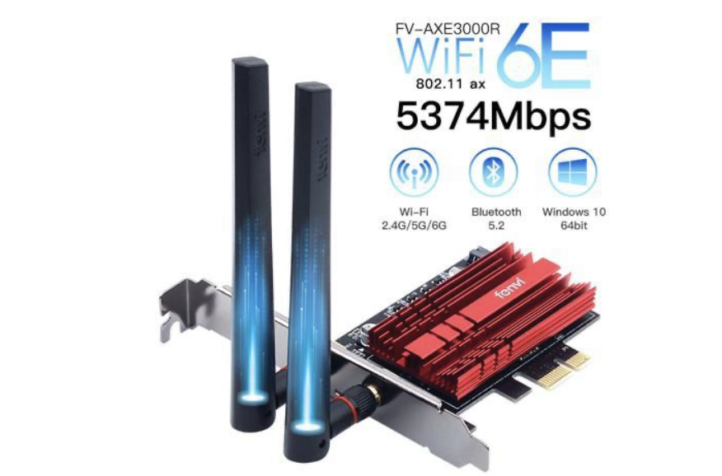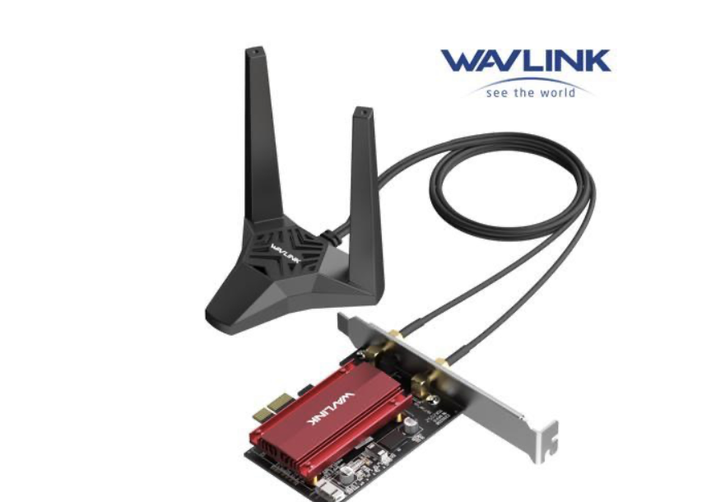 Wavlink AX3000 FenVi AXE3000R

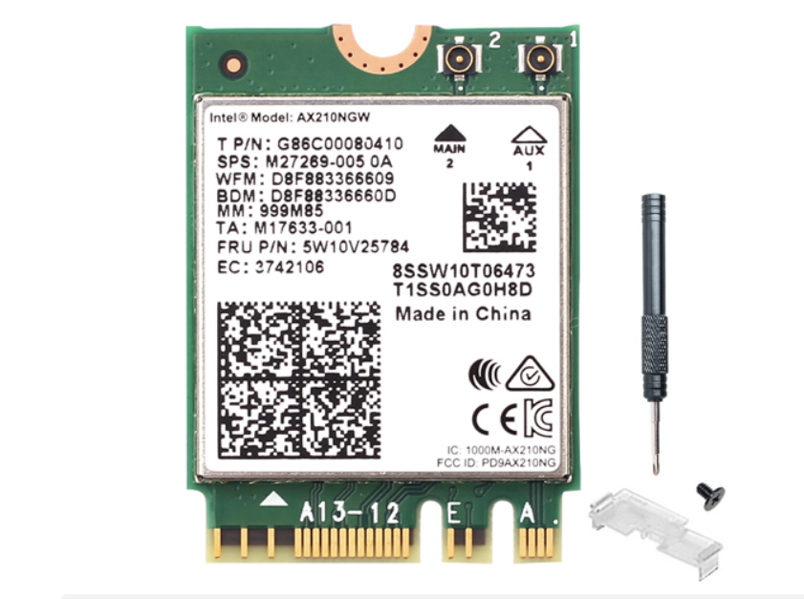Intel AX210

Each option will graded 1, 2, or 3 for each criteria. 1 is the best and 3 is the worst. Cost is weighted at 50% of total importance, security at 30%, and speed at 20%. The option with the lowest score will be the chosen option.

|  |  |  |  |  |  |  |  |
| --- | --- | --- | --- | --- | --- | --- | --- |
| Wi-Fi Card Trade Study | | | | | | | |
| Criteria | Importance | Wavlink | | FenVi | | Intel | |
|  |  | Score | Weighted | Score | Weighted | Score | Weighted |
| Cost | 50% | 2 | 1 | 3 | 1.5 | 1 | 0.5 |
| Security | 30% | 1 | 0.333 | 1 | 0.333 | 1 | 0.333 |
| Network Speed | 20% | 3 | 0.6 | 1 | 0.2 | 1 | 0.2 |
| Total Score |  | 6 | 1.933 | 5 | 2.033 | 3 | 1.033 |

Given the Results, The Intel card is the best option.

**Trade Study 2**

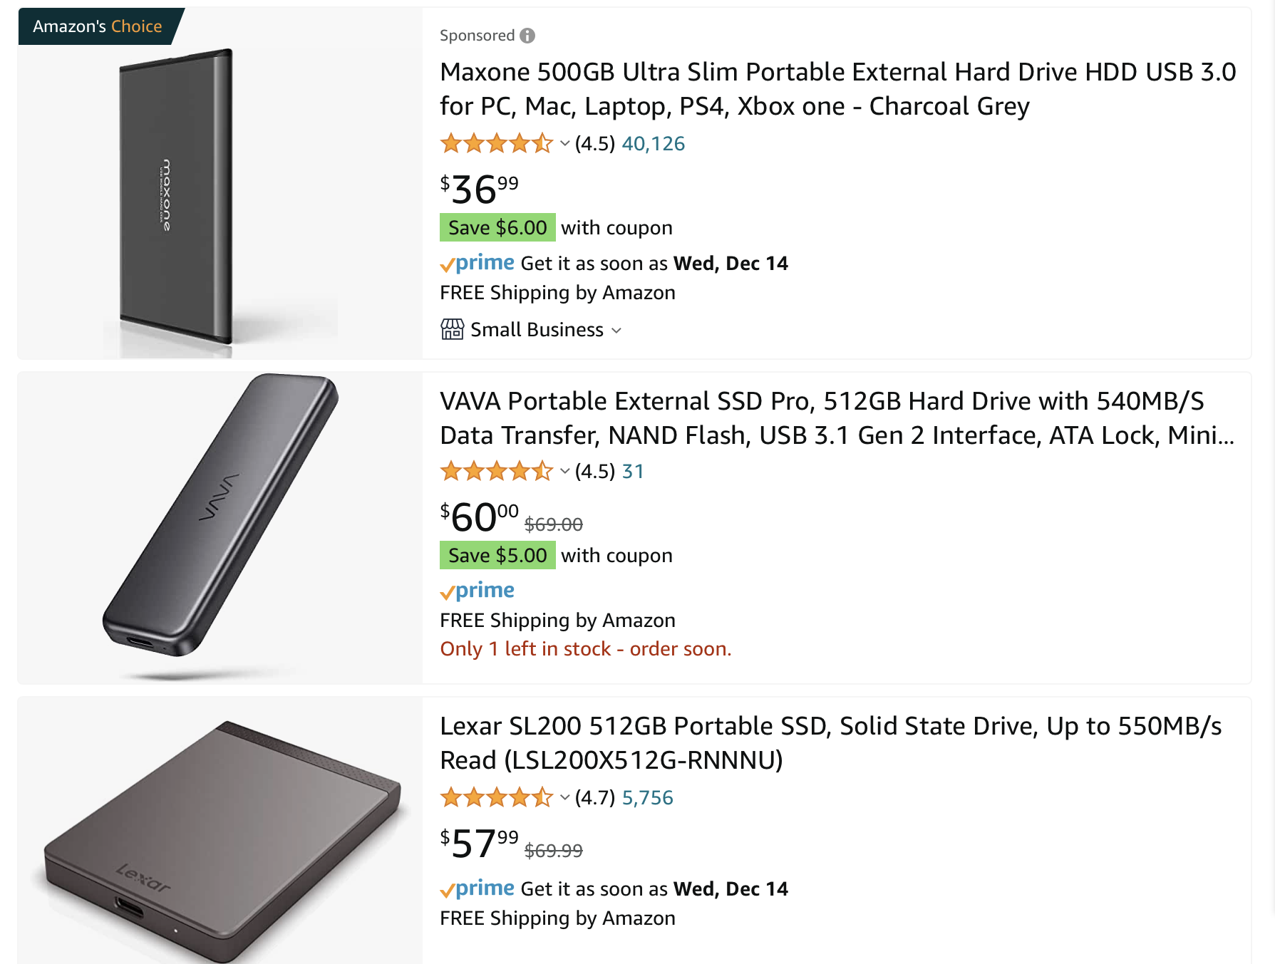There are multiple options for data storage in order to keep up to a month’s worth of test data. The options of interest are external hard drives for ease of replacement. 512 Gb hard drives will be assessed, as that is plenty of room for a month of test data. Here are the options that will be evaluated on the criteria of cost and drive speed. Cost has an importance weight of 75% and drive speed has an importance weight of 25%. The options will be scored from 1 to 3 as previously.

|  |  |  |  |  |  |  |  |
| --- | --- | --- | --- | --- | --- | --- | --- |
| Wi-Fi Card Trade Study | | | | | | | |
| Criteria | Importance | Maxone | | VaVa | | Lexar | |
|  |  | Score | Weighted | Score | Weighted | Score | Weighted |
| Cost | 75% | 1 | 0.75 | 3 | 2.25 | 2 | 1.5 |
| Drive Speed | 25% | 1 | 0.25 | 3 | 0.75 | 3 | 0.75 |
| Total Score |  | 2 | 1 | 6 | 3 | 5 | 2.25 |

The Maxone drive will be the selected option based on these results.

**Risks**

1. If the Wi-Fi card malfunctions or the local network goes out, then the system will not be able to transmit data to the company intranet.
2. If the Bluetooth functionality of the wifi card malfunctions, then the software side of testing cannot occur.
3. If the wired interface to the product fails, the test cannot be completed.
4. If the display fails, the tester cannot know if a unit passes or fails.
5. If The data on the external drive is corrupted, then test data will be lost and certain

**Summary**

The tester system should solve the problem of maintaining stellar quality control practices while accommodating the need for a faster and higher volume of production. The system was designed to accelerate the quality testing of the new door opening product. The design was completed with the idea of the tester operating in a factory environment with employees operating the tester not needing to carry out anything complex to conduct tests. The design is based on requirements which are based on the needs of the factory. Trade studies were conducted to select optimal components and subsystems. Risks were identified, but due to time constraints, considerations for mitigation were not made. However upon a first pass of the risks, most seem to have low severity. In any case, improvements can be made post-deployment. This system will help improve the production significantly and help the business save many man-hours.

1. metrics cannot be tracked.

**References**

<https://www.newegg.com/Wireless-Adapters/SubCategory/ID-31>

<https://www.amazon.com/s?k=512+gb+external+hard+drive&i=electronics&sprefix=512+gb+e%2Celectronics%2C150&ref=nb_sb_ss_ts-doa-p_1_8>